Wiki Session: Create and Personalize Workshop

Speaker: Dennis Dupps
Date: Monday, June 17, 2019
Time: 10:30 - 12:00 AM
Venue: University of Cincinnati, Baldwin Hall, Room 741

Prepared by:
Eli Rolfes, Holmes High School, Covington, KY
RET Participant for Project #5 Secure Software Development

Dennis Dupps currently serves as the Technology Resource person for the RET grant at UC. He earned BS in Industrial Arts Education at Morehead State University and a Masters in Secondary Education from UC, as well as, additional coursework in Information Technology, Computer Science, Digital Video Productions and Robotics. He has been a high school technology teacher at Indian Hill High School for the past 49 years. He served as the President of the Ohio Technology Education Association from 1984-86. He continues to teach part time at Indian Hill High School and is the faculty advisor of the Indian Hill Television Network which produces a weekly news program and many sports and musical programs throughout the district.

This talk was intended to guide RET program teachers through the process of making a wiki site for the content created this summer. Accordingly, Dennis started the session by explaining the purpose of the RET Wiki. The RET Wiki is used to create a catalog of the deliverables created by past and present RET program teachers. It includes contact information for RET participants as well as links to their own individual wiki sites. At the bottom of the home page, there is a collection of resources and templates for teachers to peruse, including workshop presentation PowerPoints and unit planning guides.

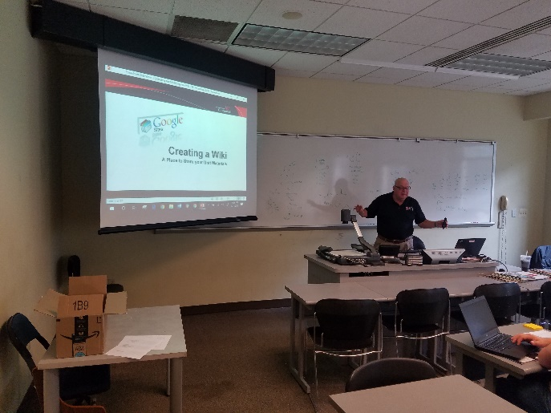
After providing a brief tour of the RET website, Dennis began a walkthrough of Google Sites website creation, see Figure 1. Following a guide posted to the RET Wiki, he helped RET teachers create their own individual Google Site. Each teacher created a wiki simultaneously as the presentation progressed. Since a template was not used, teachers had to organize the layouts of their sites. Default placeholder pages were created for unit materials and research deliverables.

Figure 1: Dennis Dupps presenting
After each teacher had his or her site created, Dennis went through the process of operating Google Sites customization tools. Teachers were shown how to upload a picture of themselves with a brief biography of their teaching assignment and educational history. Key features were overviewed. A vital feature of the wiki is to share pertinent information about the research and curricular content that RET program teachers engage in over the summer. To that end, specific instructions regarding the uploading of documents were given, see Figure 2. Since no work on the deliverables had been started by the day of the presentation, examples of expected deliverables were pulled from previous teachers’ wikis.

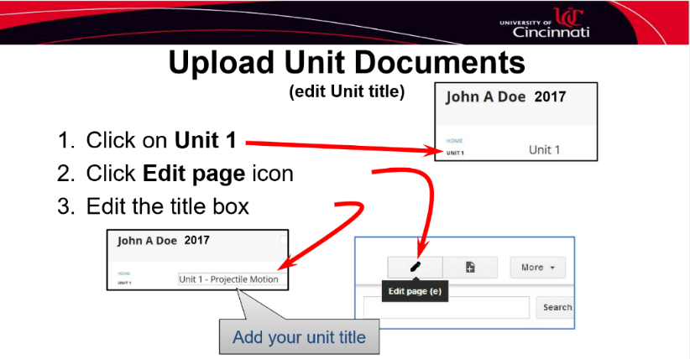
Figure 2: Slide detailing the process for uploading unit documents
The intention of this session was to provide teachers with an explanation of the way the RET program utilizes wikis to aggregate and disseminate information about the work done in the program. Dennis Dupps made sure every participating teacher had a wiki created and ready to use during the session and clarified his role of ongoing support. While no actual content was uploaded to the sites, a template was laid out to make it easier to fill in later.

